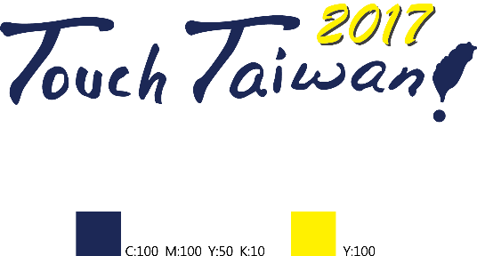 **Display International 2017**

**/**

**Date:** **Show Date: Sep. 20 - Sep. 22, 2017**

**Venue: Taipei World Trade Center Nangang Exhibition Hall 1, Taiwan, Asia Date: / /**

Application Form

|  |  |  |  |  |  |  |  |  |  |
| --- | --- | --- | --- | --- | --- | --- | --- | --- | --- |
| **Company Name** | |  | | | | | | | |
| **Address** | |  | | | | | | | |
| **URL** |  | | | | | **E-mail** |  | | |
| **Name** | | | **Tel** | | | **Cell Phone** | | | **Fax** |
|  | | |  | | |  | | |  |
| **Product Type** | | □LCD Panel / OLED Panel (Module)  □Touch Panel  □Signage Display  □Equipment/Materials/Components | | | | □Optical Film  □Flexible Electronics  □Printed Electronics | | | |
| **Booths** | | **Type of booth** | | **Original Price** | | | | **Early Bird Price**  **(until 2017/01/31)** | |
| **Raw space (9sqm,3mX3m)** | | * USD$2880 | | | | * USD$2160 | |
| **Standard Booth (9sqm,3mX3m)** | | * USD$3240 | | | | * USD$2520 | |
| **Booth(s)** | |  | | **Total Fee** |  | | | | |

**Exhibitor’s Company Chop Authorized Signature Applicant Signature**

|  |
| --- |
| 1. Products displayed by participating companies must be related to the theme of this exhibition. Otherwise, exhibition will be prohibited.  2. If the exhibition is cancelled due to a natural disaster, the organizer shall not refund the fee received or be responsible for any other claim.  3. The organizer has the right to change the layout of the exhibition area, depends on exhibit situation and demand.  4. Other attentions please refer to the usual rules of the exhibition hall. |

**Please contact: ChanChao: Tel：+886-2-26596000 ext. 182 Jane Yao / Fax：+886-2-26597000 E-mail：**[**jane.yao@chanchao.com.tw**](mailto:jane.yao@chanchao.com.tw)